4.7 Implementing STAR schema (LH & DWH)

Key points
- You can define relationships between tables, within the Model Layouts section of the Data Warehouse (or Lakehouse SQL Endpoint).

- When you create a relationship between two tables, it will do the following:

- Set the physical relationships - primary and foreign key constraints in the database

- Set the logical relationships - primary and foreign key constraints in the default Power BI semantic model.

- Note: primary key constraints in Fabric are NOT ENFORCED
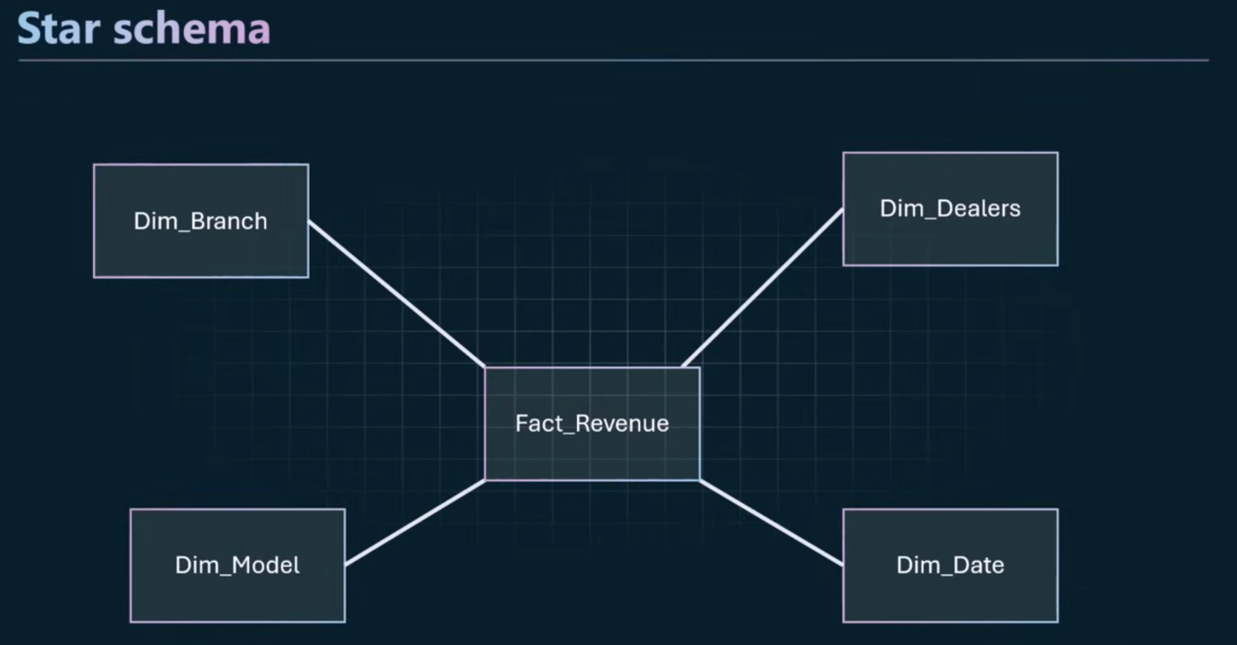
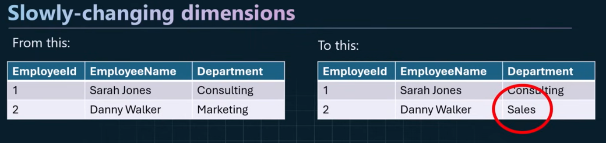
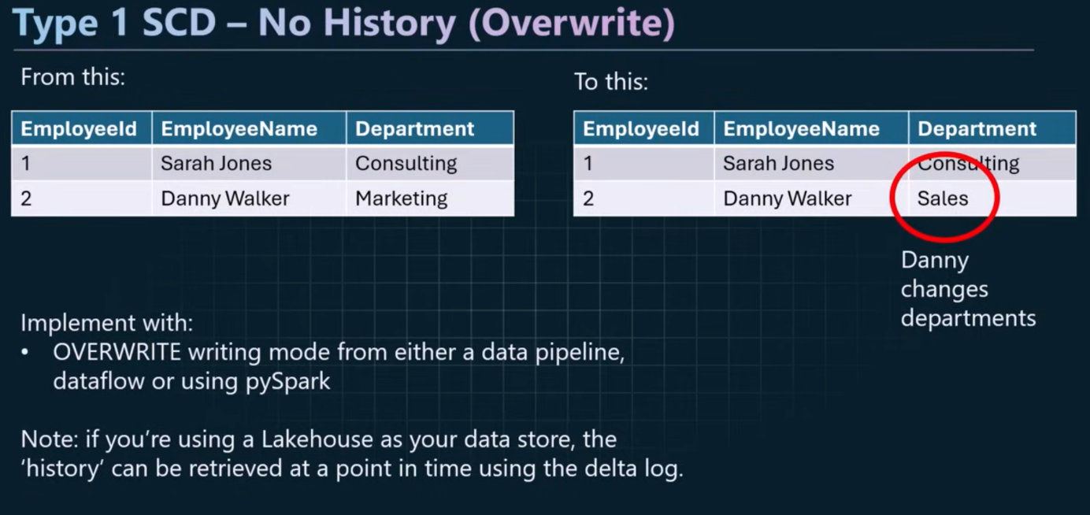
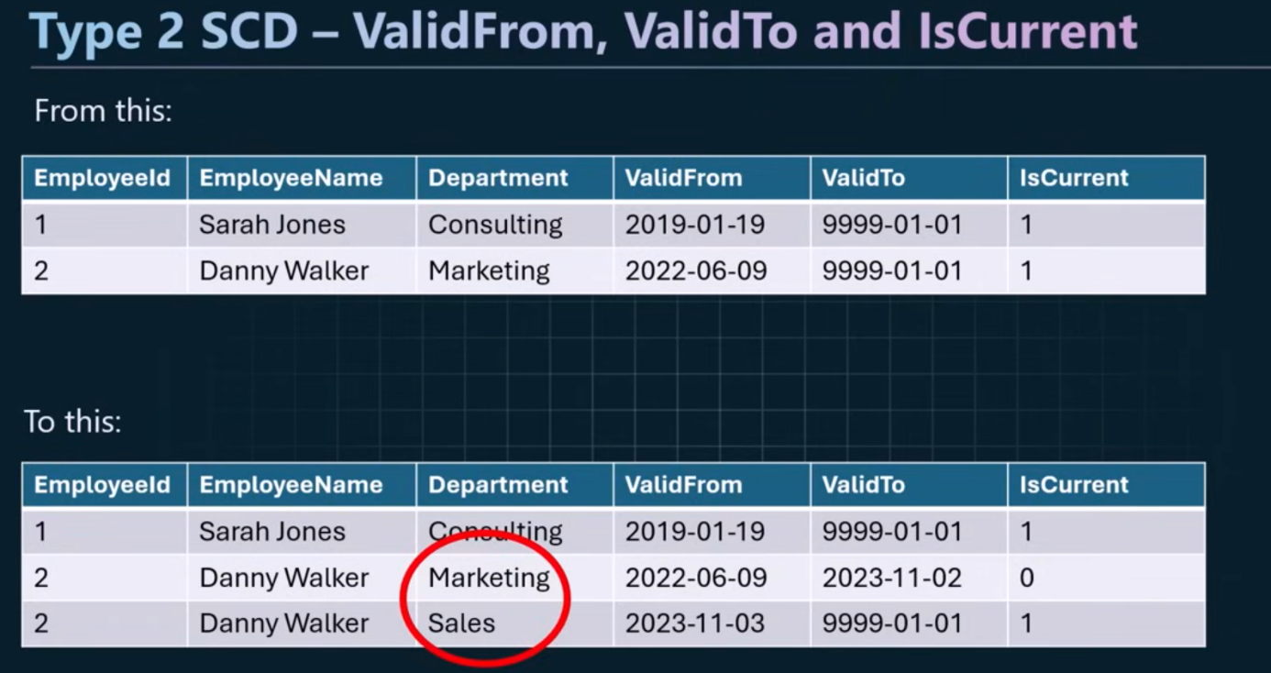
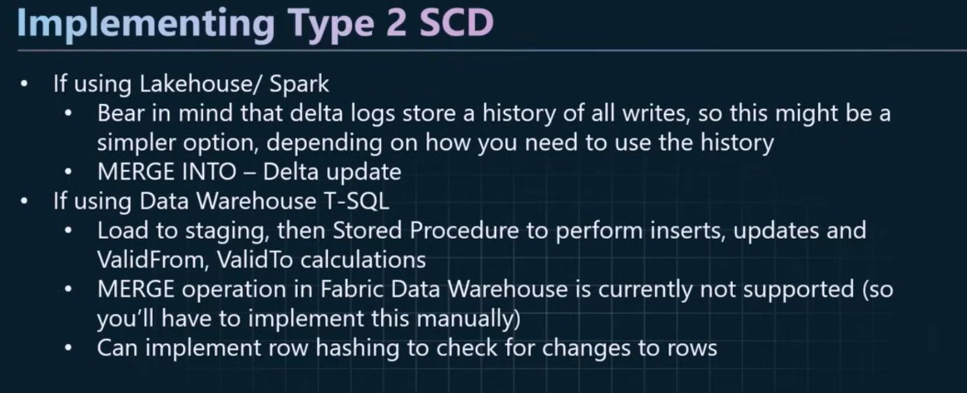

To resolve Many-to-Many relationships and implement a star schema we can use bridge tables:
